Y LIMIT BACK CABLE

- PARTS:

QUANTITY: PART #: NOMENCLATURE: LENGTH:

2 PER MACHINE 17511-1 TERMINAL, QUICK DISCONNECT N/A

2 PER MACHINE 19108- WIRE, GRAY, 22 AWG 11 INCHES

1 PER MACHINE 17585-1 HOUSING, 2-PIN N/A

2 PER MACHINE 18729- TERMINAL, CRIMP, GOLDPLATED N/A

1 PER MACHINE 46776- SLEEVE, ¼” BLACK 9 INCHES

- ASSEMBLY:

- SLIDE THE TWO GRAY WIRES INTO THE SLEEVING.

- STRIP 1/8 INCH OF INSULATION FROM ONE END OF THE WIRE PAIR.

- CRIMP AND TIN TWO TERMINALS (18729-) TO THE STRIPPED WIRES, ACCORDING TO DIAGRAM 1.

- INSERT THE CRIMPEDWIRES INTO THE HOUSING, ACCORDING TO DIAGRAM 2.

- STRIP ¼ INCH OF INSULATION FROM THE OPPOSITE END OF THE WIRE PAIR.

- CRIMP TWO QUICK-DISCONNECT TERMINALS TO THE STRIPPED WIRES.

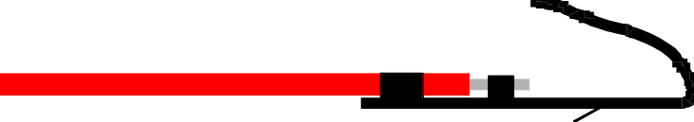

DIAGRAM 1



DIAGRAM 2

